<https://docs.blynk.io/en/blynk.edgent/overview>

<https://blynk.io/getting-started>

<https://docs.blynk.io/en/blynk.edgent/services>

<https://blynk.cloud/dashboard/506635/global/devices/4075509>

**Cài đặt Arduino IDE**

<https://www.youtube.com/watch?v=sJtJJU3c3xE>

* Arduino.cc để download Arduino IDE
* Down CP2102

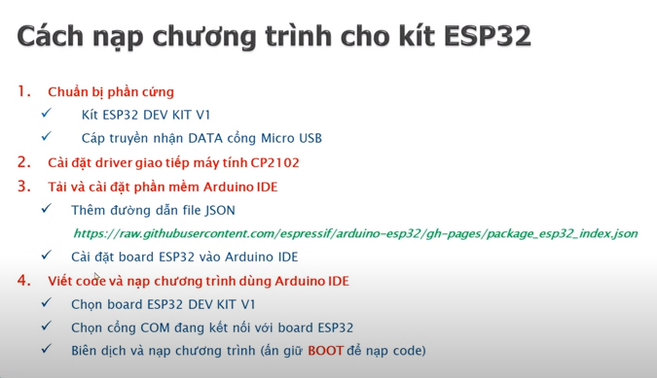

<https://raw.githubusercontent.com/espressif/arduino-esp32/gh-pages/package_esp32_index.json>

<http://arduino.esp8266.com/stable/package_esp8266com_index.json>